Computer Language Coding Concepts

Friend Declaration
This article covers friend declaration in several situations.

Friend Declaration, in a Unary Relation
The following is a unary relation:

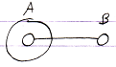

In the following picture object B is declared friend of object A:

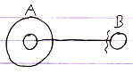

Object A can now access anything private of object B through the reference contained inside object A.

It is object B who declares itself Friend, so object B gives access to its private members.
But the friend declaration is part of A’s reference to B, because it makes the reference special, using the friend access symbol.

Friend Declaration, in a Dual Relation
The following picture expresses a dual relation:

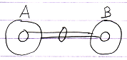

In the following picture B is declared friend of A:

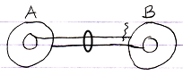

A can access everything of B, even the Private stuff. It does not go both ways: B can only access the Public contents of A.

Friend Declaration, Container is Friend
In the following picture, a related object is only displayed as contained inside another object:

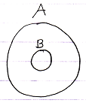

To declare A as friend of B you can use the following notation:

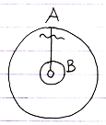

Now B can access everything of A.

Friend Declaration, the Contained is Friend
In the following picuture a related object is only displayed as the container of another object:

To declare B as friend of A you can use the following notation:

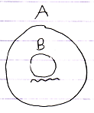

A can access anyting of B.

There is no line to place the friendship declaration on. The relation is implied by the fact that something is contained inside something else.

Mutual Friendship Referential Notation
Mutual friendship can be expressed as follows in a referential notation:

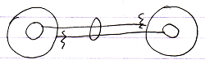

Mutual Friendship Containment Notation
Mutual friendship in a containment notation would look as follows:

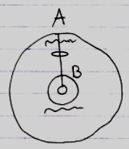

Author & Copyright: Jan-Joost van Zon Date: June 26, 2009 – July 18, 2009 Location: Oosterhout, The Netherlands Status: Finished

